Princess Sumaya University for Technology

King Abdullah II Faculty of Engineering

Electrical Engineering Department



**Microprocessors & Embedded Systems Project**

**“MEAL4PET”**

|  |  |  |  |
| --- | --- | --- | --- |
| *Authors:* |  | *Supervisors:*  *Dr Belal Sababha, Dr Esam Qaralleh* | |
| Siwar Madanat  Wajdi Hinnawi  Sileen Oweis | 20210016    20200911  20210209 | |  |

May 27, 2025

# **Abstract**

This report presents the design and implementation of an Automated Pet Feeding System using a PIC microcontroller. This system integrates ultrasonic sensing for pet detection, temperature monitoring for environmental control, servo motor for food dispensing, and flame detection for safety. The system ensures timely feeding, maintains optimal temperature conditions, and provides safety alerts (buzzer). The design incorporates PWM-based motor control, sensor interfacing, and interrupt-driven timing to achieve efficiently.

Table of Contents

**ABSTRACT** 2

**1. INTRODUCTION AND BACKGROUND** 3

**1.1 INTRODUCTION**……………….……………………………………………………………………………………………………….4

**1.2 BACKGROUND**…………………………………………………………………………………………………………………………….5

**2. DESIGN** 6

**2.1 MECHANICAL** 7

**2.2 ELECTRICAL** 8

**2.3 SOFTWARE**………………………………………………………………………………………………………………………………….9

**3. PROBLEMS AND RECOMMENDATIONS** 10

**4. CONCLUSION** 11

**REFERENCE** 12

# **1.1 INTRODUCTION**

Automated pet feeders provide convenience for pet owners by ensuring regular feeding schedules. This project implements a microcontroller-based system that detects pets using an ultrasonic sensor, dispenses food via a servo motor, monitors temperature and adjusts a fan accordingly, detects flames and triggers a buzzer alarm, and adjusts lighting based on ambient conditions

## **1.2 BACKGROUND**

The development of automated pet feeding systems represents a significant advancement in pet care technology, addressing key limitations of traditional manual methods. Because ordinary feeders require constant human supervision, feeding schedules and portion control may become inaccurate. This project uses sensor technologies and embedded system to produce an intelligent automated solution.

This system architecture centers around a PIC16F877A microcontroller, which is the central processing unit for real-time decision-making and control. Key technical components include:

1. **Mechanical control:** Pulse Width Modulation (PWM) which enables an accurate control of both the servo mechanism for food dispensing and a cooling fan for temperature regulation. Also, the servo motor is used to guarantee correct portion delivery and its angular displacement is carefully adjusted.
2. **Environmental Sensing:** Analog-to-Digital Conversion (ADC) using a linear analog sensor, which makes precise temperature monitoring possible. Also, digital flame detection sensor provides critical safety monitor.
3. **Real-Time Responsiveness:** In order to ensure the expected reaction to events that are time-sensitive (Timer0-based scheduling), critical safety triggers (flame sensor), servo control signals (interrupts from CCP modules).

The design demonstrates practical implementation of embedded peripherals (ADC, PWM, timers) for automated electromechanical control while maintaining safety monitoring through flame detection and thermal regulation.

# **2. DESIGN**

## **2.1 MECHANICAL DESIGN**

The food dispensing mechanism utilizes a servo motor and open/close a food container, ensuring controlled portion release when triggers by the ultrasonic sensor. The enclosure is designed to combine all electronic components securely while providing protection against environmental factors such as dust and moisture. The ultrasonic sensor is put to detect pet presence accurately, while the flame sensor is positioned near potential hazard zones for early fire detection, to ensure both functionality and safety in the systems operation.

## **2.2 ELECTRICAL DESIGN**

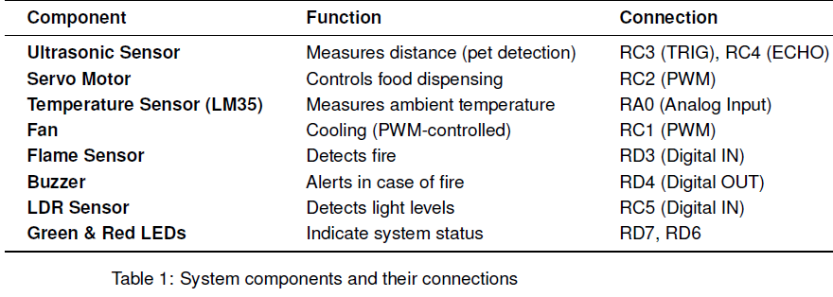

#### **Circuit Connections:**

* **PWM Signals:** Servo (RC2), Fan (RC1).
* **Sensors:** Flame (RD3), LDR (RC5), Ultrasonic (RC3, RC4).
* **Outputs:** LEDs (RD6, RD7), Buzzer (RD4), Light (RD0).

## **2.3 SOFTWARE DESIGN**

**Key Functions:**

**1. Distance Measurement (dist())**

Triggers ultrasonic sensors and calculates distance.

**2. Temperature Control (ATD_read())**

Reads analog temperature and adjusts fan speed via PWM

**3. Servo Control (interrupt)**

Uses **Timer1 + CCP module** for precise PWM generation

**4. Flame Detection (interrupt)**

Checks flame sensor and triggers buzzer if fire is detected.

**5. Light Control (LDR)**

Turns on LED if ambient light is low.

**Interrupt Handling:**

* **Timer0 Overflow Interrupt:** Used for timekeeping (feeding schedule)
* **CCP1 Interrupt:** Generates servo PWM signals (1-2ms pulse for 0-180 degrees)

**Main Loop Workflow:**

1) Check pet presence (ultrasonic)

2) If pet is near:

* Open servo after 10s delay (Tick-based).
* Monitor temperature (adjust fan).
* Check LDR (adjust light).

3) If no pet:

* Turn off fan/light, and reset timer.

4) Manual override via switch (RB0)

# **3. PROBLEMS & RECOMMENDATIONS**

The system encountered three primary technical issues during development. First, ultrasonic sensor readings occasionally varied due to environmental interference, which was resolved by implementing an averaging for multiple reading algorithm. Second, servo motor vibrations occurred from imperfect PWM signals, corrected through Timer1. Third, temperature sensor fluctuations were stabilized using average filtering.

**Recommended System Enhancements:**

1. Scheduled Feeding Accuracy: Replace delay-based timing with a real-time clock (RTC) module
2. Remote Monitoring: Add Wi-Fi/Bluetooth connectivity for smartphone access
3. Power Efficiency: Implement low-power sleep modes during inactivity
4. Safety Redundancy: Incorporate smoke detection alongside flame sensing

These proposed upgrades would improve temporal precision, user accessibility, energy efficiency, and hazard detection while preserving the system's fundamental architecture. Each enhancement addresses specific limitations of the current implementation through practical, well-established engineering solutions.

# 

# **4. CONCLUSION**

Overall, this report's Automated Pet Feeding System effectively illustrates how sensing, actuation, and embedded control can be combined to produce a dependable and effective automated pet care solution. The system successfully integrates servo-based food dispensing, temperature monitoring, ultrasonic distance measuring, and flame detection into an efficient and useful prototype by utilizing a PIC microcontroller (PIC16F877A). The system’s firmware, written in **embedded C**, efficiently manages **real-time sensor polling, PWM generation (for servo and fan control), and interrupt-based event handling**. The use of **Timer1 and CCP modules** ensures precise servo positioning, while **ADC conversions** enable accurate temperature monitoring. Despite challenges such as**sensor noise and servo jitter**, software-based filtering and timing optimizations were implemented to enhance reliability. This project validates the feasibility of **low-cost, microcontroller-based automation** in pet care systems and by combining **embedded systems design with sensor networks**, the prototype provides a scalable foundation for future smart pet feeders. The successful implementation of **PWM control, ADC-based sensing, and interrupt management** highlights the potential for further expansion into more sophisticated home automation applications.

# **REFERENCES**

[1] Textbook: Designing Embedded Systems with PIC Microcontrollers Principles and Applications, 2nd edition, 2009, Tim Wilmshurst, ISBN: 978-1-85617-750-4

[2] Hardware:PIC16F877A

[3] https://github.com/abdulazizabusaada/PetFeedingMachine